
«SERVANTS OF CHRIST
SERVANTS OF THE POOR»
Fidelity and prophecy in dialogue with the outskirts
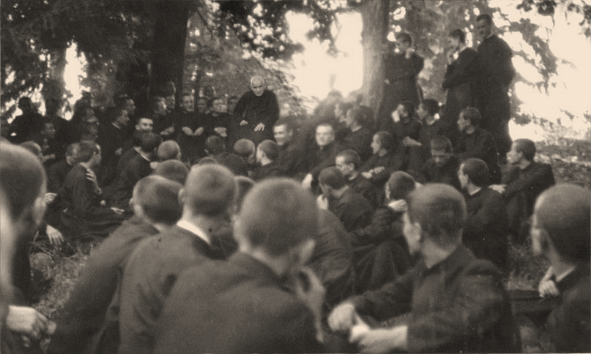
of poverty and of new evangelization

XIV GENERAL CHAPTER

Personal booklet

Sons of Divine Providence (Don Orione)

Everybody at the Chapter
for the welfare of the Congregation

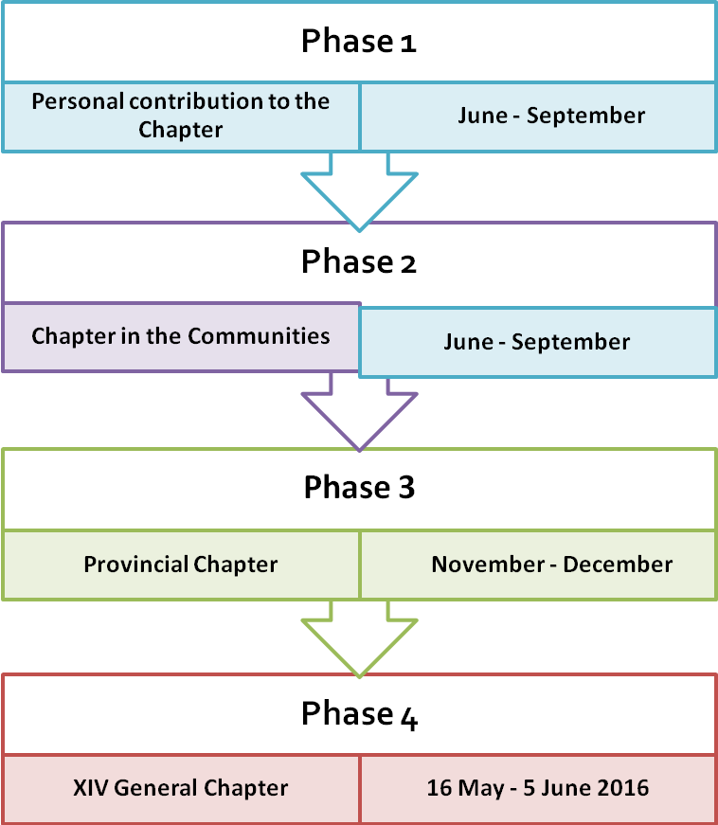

Presentation
«The General Chapter is the principal sign of unity in diversity of the Congregation. It is a very special moment in its community life. » (Cost. 138).
We will gather together «to deal with the most important problems of the Little Work, in order that it may remain faithful to the Gospel, to the spirit of the Founder» (Cost. 138). In these moments Don Orione will be with us, after-all he always remains “the Superior” of the Little work of Divine Providence.
Let us live this event as a moment of grace given to the Congregation by Divine Providence, so that, «it may respond to the needs of times and places in docility to the Holy Spirit.» (Cost. 138). It is a moment of great importance and responsibility because the Chapter gathers and processes orientations affecting the future of the Little Work which, as Don Orione would say, “is God's work”, “Providence's”. How sacred should be the esteem with which we must deal with matters regarding the life of the Congregation (cfr 1 Cor 3, 10).
Let us enter spiritually in the pattern of Pentecost all together, with our fears and upsurges, questions and uncertainties, resignations and plans; in prayer, trusting the One who is the foundation of our hope, together with Mary our “Mother and foundress”, and with Don Orione, “the Superior” in whose name we meet in the “upper room of the chapter” of each community, province, Congregation.
The general theme
The title «Servants of Christ and servants of the poor» expresses well the main features of our personal and apostolic identity. It has been taken from a definition given by Don Orione himself and indicates the central concern and object of CG 14: the personality of the orionine religious as he is. It is a matter of vocational perspective regarding the human, spiritual and apostolic identity of the person of orionine religious, of his life experience in today’s culture and the life of the Church.
The subtitle recalls the necessary dynamism of our journey of “fidelity and prophecy” in the context of “outskirts of poverty and evangelization”. Which should be our answers to the call of Pope Francis and Don Orione who want us to be “out of sacristy”, to look for the “junk of society” and for “the poorest and most abandoned”? Which orientations should we follow in choosing between well organized works of charity and “poor” answers to the new poverty? Where is the balance between pastoral care of the near ones and the new evangelization of those “far away” and those who “never come to Church”?
7 aspects of life of religious
During CG14 we will consider the personality of religious under 7 topics or fundamental aspects; they will be the object of reflection and suggestions of each religious and that of communities in the first phase of the General Chapter..

- The humanity of the religious.
It is matter of looking at ourselves: health, psychology, relationships, projects, etc. The general chapter promotes a common renewal which has to start from each religious living in the community.
- The religious lives of God.
“To live in Christ Jesus, to live of Jesus, to live for Jesus, to live Jesus” (Don Orione); the whole life of a religious is oriented to Jesus and can be understood in Him. We are called to make choices that take care of the link between us and the source of God's life from which all comes: holiness, brotherly relationship, vocational fruitfulness, apostolate.
- The religious identified in charism.
We will ponder upon practical ways to set Don Orione’s charism at the centre of our life. It is the foundation of our fraternal life, the dynamism which makes us satisfied and full of strength, able to dialogue and useful to the Church and to the world.
- Vital relationship with the community.
Cooperation is based on communion, on «vinculum fraternitatis». We will pay attention to the family spirit and make choices in favour of more authentic and simpler relationships, involving everybody in sharing spiritual and apostolic life.
- Religious in mission: witness and service.
Pope Francis reminds us often that we must be missionaries of the gospel rather than officers of rituals; we will ask ourselves on how to be shepherds of people, with the smell of the flock that is the poor, the sick, the needy and those searching for God.
- The apostolate of the Congregation: a gift for the Church.
The Church wants us, and all our works, to be orionine. We will give special attention to the challenges faced by the fidelity to the charism, in its two apostolic streams: “special faithfulness to the Pope” and the service to the “poorest and most abandoned”, through charity works.
- Towards the existential outskirts of the world
“Dear sons of Don Orione – Bergoglio / Francesco told us – you must go with your charism of foundation, to the existential outskirts, where the existence of people is junk matter. There you must go”. We will have to make choices to become an “outgoing Congregation”, in keeping with an “outgoing Church”.

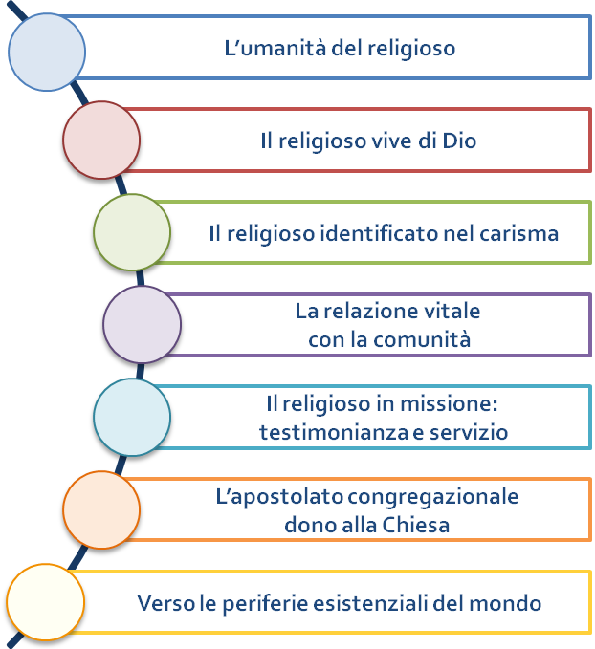
1
2
3
4
5
6
7
7 aspects
of life
of religious

Contribution to the general Chapter
A Chapter is a process that the Holy Spirit starts in the heart of each confrère awakening responsibility, availability and resources. This booklet is meant to help us to give our personal contribution to the Chapter.
We ask each religious and local community to look at their situation of life and make proposals for renewal. A personal inquiry will also be made to all religious by the use of a questionnaire, identical for all; this has been prepared and will be analysed by a team of experts. The purpose of it is to bring out the most common sentiments, thoughts, attitudes and orientations.
This Personal Booklet will help you to collect notes, reflections, suggestions and then to confront them with your confrères in what we could call the chapter of the community. A shared report for the Provincial Chapter will be sent following the same pattern of this booklet.
Provincial Chapters will be held between November and December 2015; for that reason you must send your community’s contribution by September.
Practical suggestions
Personal contribution to the Chapter. Each religious takes the Personal booklet of participation in the Chapter; spends some time reading it and to do discernment on the 7 aspects on which the theme of the Chapter is based; writes down in the booklet itself the fruit of his discernment. This process will help the work to be concrete and also ordered so that it will be easier to put together the contribution of each one. This work of discernment will be more fruitful if it is done during a day of recollection or, at least, in a moment of adoration.
The Chapter of the community (before end of September 2015). Each community must plan a time – better if continued and with moments of prayer in between – to do the Chapter of the community.
- We follow the same pattern of the personal booklet.
- Each person presents the fruits of his personal discernment while everyone listens to him.
- We start a community reflection trying to reach an accord while prioritizing some points to be presented.
- A person in charge will write down the points shared on each aspect and then put them in order: this will be the contribution of the community to the provincial chapter.
Note 1. Any other contribution to the Chapter by a religious can be sent directly. These can be about a) the general theme of the Chapter (form 1), other topics regarding the life of the Province or of the Congregation (form 2). These personal contributions should be prepared filling in the appropriate form in order to facilitate their use.
Note 2. Follow the method. This is the challenge of every chapter. The Congregation is big, with different nations, situations, languages. By following the same method we can avoid confusion and the loss of contributions of confrères or provinces. The contributions of the confreres are the basic starting point of the Chapter which is called General because all religious participate in it and not because some representatives do.
Note 3. Which kind of participation will PSMC, ISO and MLO have? In which way can they be inserted in the different moments of discernment? We can find an answer in art. 140 of our constitutions, adapting it to the local situation. It is a good thing that each community asks the opinion of those who can give good suggestions on the areas of their concern. The proposals to the Chapter must be made by religious only.
Note 4. Some aids. We have prepared a triptych (threefold icon) which can be exposed in all our chapels or in the community room as reminder of the Chapter. We prepared also a holy card with the prayer for the Chapter to be said daily. Finally there are also some cards to help us to reflect on the encyclical letter “Evangelii Gaudium” and on the text “Anime Anime” by Don Orione from which the theme of the 14th general chapter is taken.
There is enough material to start well our journey. Let us put ourselves in the presence of the Lord with humility and simplicity, willing to discover and offer whatever we, while in front of Him, see useful for the common welfare.
Hail Mary and forward towards the General Chapter of 2016.
Don Flavio Peloso FDP
(Superiore generale)

THE HUMANITY OF THE RELIGIOUS

“Where are you?” (Gen 3:9)
Adam it’s you! And it is God who is turning towards you and asking, “Where are you?”; “how are you?”; “what are you looking for?” “Are you content with your life? Do you fell fulfilled as a person?” Pope Francis invites us not to be afraid “to show our joy at having responded to the Lord’s call”, not to be sad, “with a long face...with a face like a “pickled pepper”; and he reminds us that “this is the beauty of consecration: it is joy, joy.”
Let us look at ourselves: health, psychological aspects, relationships, plans for the future etc. Let look at our confidence and attitude towards the future.
The Congregation is made up of people. The General Chapter is promoting a renewal of all together, but starting from each religious in communion with the others.
Weaknesses are part of our humanity, and touch each religious, communities, and the Congregation. We should accept them with spiritual and practical compassion as an opportunity to evangelise our life.
- Do I feel well as a person? Some indicators are: a good awareness of myself and my history, the joy of consecration, confidence in the future, the ability to love, sensitivity towards my brother in community and in the apostolate, responsible and calm relationships, pastoral enthusiasm and interior oneness with Christ.
- Are their gifts and limitations which I have to take into account on my journey, as I try to develop the first and overcome the second?

Notes on the situation

Suggestions for improvement

THE RELIGIOUS LIVES OF GOD

“The love of Christ drives us on” (2 Cor 5:14)

It is looking at and habitual contact with the “source” and the “dawn of the first love” which has filled and nourishes our life today, “a "Thou" who calls us by name” we are called to be “living sources of water” from which others can drink God.
“To live in Christ Jesus, to live of Jesus, to live for Jesus, to live Christ” (Don Orione). The whole life of a religious is focused on Jesus and is understood in Him. “The more you unite yourself to Jesus and He becomes the centre of your life, the more He makes you go out of yourself, become less self-centred and open yourself to others”.
Consecration is not a way of making sure that the services provided by charitable institutions and Church bodies function, but it is the basic content of the mission of consecrated people. For religious life is the following and imitation of Christ. It is the “living reminder of the way of being and acting of Jesus as the Incarnate Word.” As far as possible it is the visible expression of “the way of life, which the Son of God lived when he came into the world.”
We are neither better nor worse than others. We are different if we go directly to the source of life: the life of God, imitating the celibate, poor and obedient Jesus for the sake of the Kingdom of Heaven.
- How is the vital link to the sources of charity in God from which flow down all the actions of God in us, in fraternal relationships, in vocational fruitfulness, in the apostolate and in the journey of renewal? Is the understanding of the specific nature and beauty of our vocation strong in us? What personal and community choices need to be made?

Notes on the situation

Suggestions for improvements

THE RELIGIOUS INDENTIFIED IN THE CHARISM

“Everyone has his own gift from God” (1Cor 7:7)
We “like a family in Jesus Christ” and what unites us and nourishes our belonging, our identity and our mission as Christians and religious is the same charism. “To be Orionines, that is, to live the spirit of Don Orione, is an act of love for Jesus from and the charism comes from Him and leads to Him. It is also an act of love for the Church; and she asks us to be “Orionines” because the charism is a gift for the Church and it both enriches it and makes it more beautiful. It is also and act of love for Don Orione: “Not he who says Don Orione, Don Orione, but he who lives the spirit...is a son, a disciple”.
The charism of the Congregation, as a specific value of the Gospel, needs to be put continually at the centre of our life through the study of Don Orione and of the Constitutions today, so that we may live its inspirations and challenges and not simply repeat the responses already given. Only in this way shall we be able to be in dialogue and useful to the Church and to the world.
- How can we courageously make our own and express our charismatic identity better?
- How much are the sense of belonging, identity, personal, community and pastoral life-style alive and strong and inspired by the Orionine charism? How should we nourish and make the family spirit concrete? How is the sense of belonging in the Province (Delegation)and the Congregation, which is a sure indication of vitality and vocational fruitfulness, expressed?
- “Pastores dabo vobis”, 31 states that “priests, who belong to religious orders and congregations, are a spiritual richness for the entire diocesan clergy, to whom they offer the gift of specific charisms and specialised ministries”. Does my service and ministry, including the priesthood, have the form and dynamism of the Orione charism?

Notes on the situation

Suggestions for improvements

1

LIVELY RELATIONSHIP WITH THE COMMUNITY

“You are all one in Christ Jesus” (Gal 3:28)
In the Church, religious communities are “houses and schools of communion”. What does this mean in practice? Before making plans of co-operation we need to promote a spirituality of communion and give it the importance of an educational principle in the field of relationships. “Let us not deceive ourselves: without this spiritual journey, external instruments of communion are of little use. They would become structures without a soul, masks of communion rather than its ways of expression and growth”.
Communion in our religious communities is the fruit of a vocation and relationship with God. If the relationship with God diminishes, the “vinculum fraternitatis (bond of fraternity)” breaks, because our communities, are a gift of the Spirit, rather than a human construction. “In fact, the religious community has its origin, and is built as a true family gathered together in the name of the Lord, from the love of God poured into hearts by means of the Spirit”.
“How can you yourselves know, if you are faithful to your vocation?” , said Don Orione. “If a person wants to measure the temperature, the fever, he uses a thermometer. There should be some type of thermometer to enable us to measure whether we are faithful to the Holy Rule, to our holy vocation. There is such a thermometer: it is community life”.

Note sulla situazione

Suggestions for improvements

THE RELIGIOUS IN MISSION: WITNESS AND SERVICE
“The first Christian Community....was admired by all the people and the Lord added to its number every day those who were saved” (Acts 2:42-48).
Pope Francis reminds us often that we must be missionaries of the Gospel and not sacred officials. We must be shepherds of people, with the smell of the sheep on us, above all of the poor, the sick, people in difficulty and in search of God.
A religious, because he is a disciple of Christ and a man of God, is meant to be a “witness” of the new life according to the Gospel and, therefore, shepherd, prophet, animator and formator, guarantor of the charism”.
“Charity, as far as the Church is concerned, is not a type of welfare activity which it could leave to others, but belongs to its nature, and is a fundamental expression of its essential being”. In order that ours should be “an activity which savours of the eternal and divine” we must be “mixed and kneaded with the sweetest charity of Our Lord” through a genuine and holy spiritual life.
- Are our personal life, the community and the organisation of the apostolate nourished by and do they nourish genuine witness?
- Does the dichotomy between genuineness of life and charitable and pastoral activities render our apostolate ineffective (DCE, 42). What are the new challenges facing our charitable apostolate?
- What choices need to be made in order to overcome the split between “spirituality” and “service”, between “service” and “evangelisation”?
- How can we fulfil in practical terms the longing and the desire for more direct relationships between religious and the people whom we are called to serve, between religious and institutions, keeping in mind the way in which relationships have generally become more impersonal and digital?

Note sulla situazione

Suggestions for improvements

CONGREGATIONAL APOSTOLATE GIFT TO THE CHURCH

“To each is given a particular gift of the Spirit

for the common good” (1 Core 12:7)

“It is the Church that wants us to be what we should be, Orionines, we and our parishes, Orionine our schools, Orionine our works of charity, Orionine our Lay People and Young People! Orionine! That is what we are here for. The charism is the reason and the mode through we the Congregation herself exists. Every charism has been raised up for the well-being of the Church. Either it is “that good” given by the Spirit or it will not work or have any future”. “It is to the Church’s own advantage that the institutes have their own unique identity and their own unique function.”
Today, in a fluid culture which is uncertain and inconsistent and which whittles away at identities, let us fix our attention on two lines of our faithfulness and Orionine sense of belonging.
- “To unite to the Pope in order to establish all things in Christ is an essential part of our vocation.” Don Orione already had to face “the objection, that had been made, and that would be made perhaps in the future against the institute, because of its universality in carrying out the works of mercy” and therefore on the “its uniqueness compared with all the other religious institutes”. Don Orione states that the institute “has one fixed aim” and that is “the sanctification of its members, together with spreading the sweetest love for the Holy Father among the Christian People” .
- How to live a “special” and not generic “faithfulness to the Pope”? How to make every activity of the Congregation converge to the papal-ecclesial aim?

- “We are for the poor, rather for the poorest and most abandoned”, as Don Orione used to say, for “those who have protection from somewhere else, there is already the providence of men, we, on the other hand, are of Divine Providence”.
- How to put into practice in today’s situations this charismatic uniqueness which describes our identity and our mission? How to balance the “first aid” works of charity with those of “specialised human promotion”, the big charitable and educational institutions with the “new responses, which are easily adaptable, light and less institutional”?

Notes on the situation

Suggestions for improvements

TOWARDS THE FRINGES OF EXISTENCE IN THE WORLD

“Jesus...felt compassion for them, because they were tired and exhausted, like sheep without a shepherd” (Matt 9:36).

“Dear sons of Don Orione must go with your founding charism to the fringes of life, to where people’s existence has been discarded. You know that you are in this system which is worldly and paganised. There are those who have status (caben) and those who are leftovers (sobran). Those who are not in the system are leftovers and those who are leftovers are rejected (descartables). These are the fringes of existence. There you must go. Or perhaps you prefer to go to the ones who are satisfied, to the people who are in a good position, to those who lack nothing? No, to the fringes of existence.”
- The invitation of Pope Francis to “go to the fringes of existence” corresponds to the “out of the sacristy” of Don Orione. The concept of “descartables” of the Pope is very similar to that of the “abandoned/”desamparados” of our Founder. What choices are needed to revive today the movement towards “the poorest and most abandoned”?
“We must go and move with the times and ahead of the times and the people....then we shall remove the abyss which is developing between the people and god, between the people and the Church”; “we must be the advance guard of the Church”, “to go where others do not go”, with “apostolic boldness”, with “a spirit of first aid”. A palm tree does not produce bananas in Poland and a vine does not mature fruit in the Ivory Coast and the Little Work does not grow behind the front but “in the front line”.
- Are we a Congregation “in the front line” with regard to poverty, with the problems of people and society and with the commitment to evangelise according to the drive of Don Orione?
- What choices need to be made in order to bring up-to-date the relationship between the traditional works and the new forms of poverty, between the apostolate to those who are near to us and the new evangelisation of those who are “far away”, “those who do not go to church”?

Notes on the situation

Suggestions for improvements

Card 1:
For other contributions on the main Theme
(which where not included in the 7 aspects)

Surname:___________________ Name:___________________
Province/Delegation: _____________________________________
Our situation:

Suggestions for improvements:

To be sent to the Delegation Secretary/Superior

Card 2:
For personal contributions on any other theme
(which are not included in the general theme)
Surname:___________________ Name:_____________________
Province/Delegation:_____________________________________
Object (Title):

Proposal:

Motivations:

To be sent to the Delegation Secretary/Superior

PRAYER

Good and provident Father,
We want to carry deep within us
Contemplative and active spirits,
Servants of Christ and the poor,
The Divine Treasure of your Charity
That it may pervade all levels of society.

Jesus, our Redeemer,
Who poured out your Divine Blood from the Cross
For the salvation of Souls,
Make us on fire with faith and charity,
So as to open a new and divine world to many people,
To bend with charitable sweetness
And with understanding for the little ones, the poor and the humble.

Holy Spirit, fire of love,
Pour out on us such a shining light,
Such a life of love of God and people
That all may experience the flame which burns in our heart
And find You our God and Christ.

Virgin Mary,
Mother and heavenly Foundress,
Look after this Congregation which is yours from the beginning;
To you we entrust our intentions
And commitment for the 14th General Chapter.

Saint Luigi Orione, pray for us.

Main text of reference, from which the title is taken, is one of the most famous pages by Don Orione. Is made up of some personal notes, dated 25 of February 1939. By these notes Don Orione delivers his own life, ideals, charism, to his disciples. Here we can find the famous “canticle of souls” as well as all main points of orionine anthropology, its human, spiritual and apostolic features. These notes cover several papers. You may find them in Scritti 57, 103 – 104 (a-d); they were also published and commented in Sete di anime. Un brano di Don Orione commentato da fra Filiberto Guala, “Messaggi di Don Orione” n.10, 1972.
Meeting with seminarians and novices, Aula Paolo VI, 6th July 2013.
“The duty and beauty of our vocation is to struggle for perfection, convinced that this means giving oneself to God seriously” (Constitutions art. 14), and for this reason we are “the first to be concerned about a suitable formation at every stage of religious life” (Constitutions art. 82) because “Life is not a simple product of laws and the randomness of matter, but within everything and at the same time above everything, there is a personal will, there is a Spirit who in Jesus has revealed himself as Love” (in Jesus (Spe Salvi, 5). Also our “love is never finished and complete. It transformed in the course of our life, matures and because of this remains faithful to itself (Deus caritas est, 17). “If you don’t go forward you go backwards”.
Cf. Constitutions art. 21.
Lumen Fidei 8
Evangelii gaudium, 86
Rallegratevi (Rejoice), cf. Note 29. “When things are not seen with the eyes of faith, life gradually looses meaning, the face of our brothers and sisters become opaque and it is impossible to discover the face of Christ and historical events are ambiguous if not without any hope” (Starting again from Christ, 25).
Vita Consacrata, 20.
Lumen Gentium, 44.
Philippians 2:5; Vita Consacrata, 18.
Constitutions art. 59.
F. Peloso, Circular Letter Vocations, vocations. The youth-vocations apostolate, 28th August 2007.
John Paul II, Apostolic Letter Nuovo millennio ineunte (6th January 2001), n. 43.
Ibidem, 43.
Fraternal life in community, 8, “The Church has an urgent need of fraternal communities in order to present to humanity today its true face. These communities, by their very existence, are a contribution to the new evangelisation, because they show the fruits of the “new commandment” in a concrete way” (Vita Consacrata, 45).
Parola, 12th April 1918.
Cf. Evangelii gaudium, 24.
Cf. 13th General Chapter, line of action n. 20. “Consecrated men and women, even though they carry out many services in the field of human formation, care of the poor, teaching and help to the sick, know that the principal aim of their life is “the contemplation of divine realities and constant union with God” (canon 663, 1). The essential contribution which the Church expects from consecrated life is much more in the area of being than of doing” (Benedict XVI, Sacrament of Charity (22nd February 2007), 81).
Deus caritas est, 25.
Pope Benedict XVI said to us Orionines, “Works of charity, whether personal acts or services to weak people in great institutions, can never be reduced to a philanthropic gestures, but must always be tangible expressions of the providential love of God. In order to do this, as Don Orione reminds us, it is necessary to be “mixed and kneaded with sweetest charity of Our Lord” through a genuine and holy spiritual life. Only in this way is it possible to “pass from the works of charity to the charity of the works, because, adds our Founder, even the works without the charity of God, which should give them value in his eyes, are worth nothing””.
Fr. Peloso, Vocation, vocations. Youth-vocation apostolate, 28th August 2007.
Perfectae caritatis, 2. Don Orione fixed his charism with the dual name “Pope-Poor” or also “Papality-charity”. The fourth vow of “special faithfulness to the Pope” of the Sons of Divine Providence and “charity” of the Little Missionary Sisters of Charity is the canonical expression of the two faces of the same charism.
Plan and programme of the Little Work of Divine Providence, 1903: Letters I p.6 (The priceless treasure)
Scritti 72, 185.
Spirito di Don Orione I, 36; II, 71; 107; Scritti 108, 55; F. Peloso, Circular Letter “Let it be clear to all that the Little Work is for the poor” of 24th May 2010.
12th General Chapter, “Mission”, Guidelines, n.7.
Jorge Mario Bergoglio, Video message, Buenos Aires, 9th November 2009. “ Religious families are born to inspire new ways, to offer undreamt of methods or to respond with agility to human and spiritual needs. It can happen that consecrated life loses its authority, its charismatic boldness and evangelical simplicity (parresia) because it is attracted by lights which are not within its identity” (Scrutate 14-15)
Scritti 20, 97b; Letters I, 65 (A priceless treasure).
Parola21.3.1938, VIII, 219.

