CALLING FOR THE 15th GENERAL CHAPTER

“Let us throw ourselves into the fire of the new times”

To Evangelize the world through the Prophecy of Charity which must be new in the style, form, and frontiers

Souls, Souls!
Rome, 31st May 2021
My dear Confrères,
the Sons of Divine Providence,

With this circular letter of mine, on the Feast of the Visitation of the Blessed Virgin Mary, in accordance with Article 139 of the Constitutions, I convene the 15th General Chapter, which will take place at our Spirituality Centre in Montebello della Battaglia (Pavia - Italy), from 31 May to June 18, 2022.
As it happens every six years, the time has come to listen to our Founder even more strongly, so that the Congregation may be able to discern what Divine Providence wants from us in this historical juncture. From now on, we will follow a synodal journey, in all its aspects, so that the Chapter may be for our Religious Familythe "main sign of unity, in diversity" and the "very special moment in its community life, as the Constitutions say." (cf. Const. art. 138).
It is the beginning of an itinerary which, in its dynamism and various stages - personal, community, provincial and general -, will give us the opportunity to "deal with the most important problems concerning the life of the Little Work, so that it may remain faithful to the Gospel, to the spirit of the Founder and so that it may respond to the needs of times and places in docility to the Holy Spirit" (cf. Const. Art. 138).
The time of preparation, that is from now, will also be a time for us to pray, reflect and share. These are the necessary conditions for the Holy Spirit to inspire us to be faithful to the Gospel and the Founder. Only with prayer it will be possible to create such a spiritual climate as to arouse in the whole Congregation the desire and impulse of conversion, the mature fruit of the Chapter event.
Dear Brothers, let us pray, and make others to pray too, for the success of the 15th General Chapter. Let us pray, personally and in our communities. Let us ask our Sisters, the members of the Secular Institutes, our laypeople of the Lay Movement, and, above all, our poor, to pray for us.
Let us invoke the intercession of the saints of our family! Led by St. Luigi Orione, they may obtain for us the grace to conform to the Lord's design. Let us entrust ourselves also to the maternal protection of Mary Most Holy, our Mother, and Heavenly Foundress, so that the Chapter may be an event of grace for our Congregation.
Finally, allow me to express a further desire: that the text of this letter of convocation may become the object of personal and community meditation. We must do this, not only to possess better its content and better prepare ourselves to live the dynamism of the journey to the Chapter, but above all, to be able to contribute to the reflection and the choices made with personal and community contributions, in the various stages of participation.

“Let us throw ourselves into the fire of the new times”

To Evangelize the world through the Prophecy of Charity which must be new in the style, form, and frontiers.
The expression that gives the title to our next Chapter - "Let us throw ourselves into the fire of the new times" - is a sentence that recurs several times in the writings of St. Luigi Orione.
On 6 October 1918, the First Meeting of the Diocesan Propagandists of the Popular Union took place in the premises of Bishop’s house in Tortona. Don Luigi Orione was also present at the meeting. His passionate appeal is reported in the minutes: "Humanity, afflicted by so many evils, needs to refresh in faith: it needs the heart of Jesus Christ. Let us go to the people and bring them Jesus Christ ... There is an urgent need and duty to throw ourselves into the fire of the new times, for the love of Jesus Christ and the people, as well as the country, since humanity today supremely needs to be refreshed in faith and to come back to live in the charity of the heart of Jesus Christ: charity to the souls of people and charity to their bodies: a charity that will be justice for everyone in society to raise the people to Jesus Christ by beginning to heal their moral wounds with faith and by bringing them to Christian life, but from here go also to the social wounds and help them in every way" (Scritti 52,221).
The day after the meeting, Don Orione, from Tortona, informs a friend of his who was a Canon of the Cathedral, with these words: "Dear Canon, the meeting went quite well ... now, we cannot go on looking sadly at ourselves: we must make a sign of the cross and throw ourselves into the fire of the new times, out of love for Jesus Christ, for the people, who invoke a remedy for their pains…” (Scritti 31,21).
In other undated minutes, we find the same heartfelt appeal: "Let us make the sign of the cross and throw ourselves trustfully into the fire of the new times for the good of the people: the cause of the people is the cause of the Church and of Christ himself ... let us not wait for the war to end: Caritas Christi urget nos" (Scritti 75,242). And again: “Let us throw ourselves into the fire of the new times to do good, let us go into the midst of people to save them. We will always find new faith and new courage to work if we do not work for human purposes. Let us plow and then re-sow Jesus Christ in the soul of people: humanity today supremely needs the Heart of Jesus Christ " (Scritti 79,287).
These words are particularly illuminating for the preparation and implementation of the General Chapter. Willing to listen to Don Orione during this time of the chapter, we have chosen to make his method to become our own, for dealing with the "new times", his attitude of readiness to dialogue with reality, and his ability to react and answer to his way, with the imagination and strategies of charity. Finally, we want to be able to dream his dreams, with his apostolic ardour and his fidelity to the Church.
We will also be guided on this journey by the stimulating Magisterium of Pope Francis, which we recognize deeply in tune with what our Founder wanted. In fact, the Pope in 2016, on the occasion of our chapter said: "With Don Orione, I too urge you not to remain closed in your works, but to go outside." (27/05/2016). These words, repeated today, particularly in the context of the various "lockdowns" caused by the health emergency, resonate with relevance. The same do these words of our Founder: “Are these new times? Away with fears, let us not hesitate: let us move to overcome them by an ardent and intense apostolic spirit of healthy, intelligent modernity. Let us throw ourselves into the new forms and new methods of religious and social action, under the guidance of the Bishops, with firm Faith, but with common sense and a generous spirit.” (Scritti 79,300).
“Let us throw ourselves…”: The reasons for the choice
In preparing the Chapter, the General Council made use of the suggestions gathered during the Verification Assembly (October 2019), the proposals received from a consultation with the Provincial Councils (October 2020), and the responses of the confreres to the online survey carried out in 2020. The latter had a great impact because the confreres added many important spontaneous indications for the Chapter.
a) An Orionine expression - Let's throw ourselves...
The first and certainly the strongest reason that led us to choose this expression is its reference to the paradigmatic attitude of Don Orione, always striving to take action in favour of the Church and the poor, despite the complexity of the times and situations that he had to face. As we have seen by recalling only a few passages from his writings, this it is a strong and typical expression of the Founder, in which he expresses himself with "missionary audacity". For him, as we know, it was a question of "throwing himself into reality" with a contemplative gaze and with apostolic initiative. The expression, therefore, belongs to us and is an Orionine brand!
b) A synodal expression - Let's throw ourselves...
It is an invitation, not a directive! It is an appeal, to be accepted with all freedom. It is not a military order! It is an exhortation, almost a prayer! To be fulfilled in the plural and not in the singular; in fact, Don Orione does not simply invite us to “throw oneself”, but to “throw ourselves”, setting up our movement according to a community and congregational dynamism. Thus he fully inserts us into a synodal perspective to make us travel together a path of conversion. So, the Chapter is already an answer and a proposal: “Let us throw ourselves into the fire of the new times”.
c) A "verbal" expression - Let's throw ourselves ...
It is a simple, engaging, intuitive, and very powerful sentence, which immediately communicates the strength of the "verb", the action, putting us in a perspective of movement. In giving preference to the "culture of the verb", we leave aside the "culture of the adjective", which can easily lead us to self-referentiality. In this way we are in harmony, not only with the Founder's thoughts, those of "Out of the sacristy" and "It is urgent to start!", but also with the insistent thought of Pope Francis who urges us to "go out", to be an "Outgoing Congregation".
d) An expression that puts us in the line of continuity with the last Chapters
Faced with a title that strongly emphasizes the word "new", someone might comment: "But do we have to restart all over again? What happens to everything we have done so far? Isn't it worth anymore? Were the efforts done, useless? ”. Renewal does not mean throwing everything away and starting all over again, but relying on what has already been done and restoring vigour and enthusiasm to the confreres to continue. On the other hand, Don Orione too, in his life, also made radical changes, but his focus never changed, nor did his desire to save souls; indeed, it was precisely this desire that prompted him to make changes in his program and lifestyle.
This chapter, in launching the proposal for renewal, invites fidelity and continuity. After the 13th GC that was under the title of "Only charity will save the world" as a "dynamic of conversion and spiritual, community and apostolic renewal" and after the 14th GC which focused on the person of the religious "Servant of Christ and the poor", it seemed right to us to propose an itinerary of reflection and go deeper in those dynamics, so they could put the Congregation in an apostolic attitude "of going out". We do it to welcome, in the present day of history, the perennial invitation of Don Orione – It is urgent to start! - and the current appeal of Pope Francis - we must go out to bring God's mercy to everyone! Obviously, we will also be in line with the previous Chapters: we want “To Be Don Orione, today” (10GC), “Religious and laypeople on the mission” (11GC), “in creative fidelity” (12GC). This not only for a thematic approximation but above all for a qualifying content, that is, by combining reflection on our identity and on the new times we live in, with the choice of a courageous apostolate. In other words, if it is true that the “being” is at the basis of acting, it is also true that, from the charismatic point of view, good acting gives substance to our being, in all the dimensions that constitute it: human, social, spiritual and religious.

“…into the fire of the new times”: a methodology for the work
“New times are ripening: let us prepare ourselves in Christ!” (Scritti 106,148). How can we welcome the newness of the times we live in, with Christian hope and Orionine style? Times of which Pope Francis, on 21 December 2019, in a prophetic way, said: “We find ourselves living at a time when change is no longer linear, but epochal. It entails decisions that rapidly transform our ways of living, of relating to one another, of communicating and thinking, of how different generations relate to one another and how we understand and experience faith and science.”.
In every moment of our history, the Chapters have launched proposals for renewal of the Congregation, provoking the religious to develop dynamisms of actualization of the charism. The 15th fits into this same trail and, “Attentive to the promptings of the Holy Spirit who helps us together to read the signs of the times” (cf. EG 14).
The General Council after having listened to the religious, the Provincial Councils, and taking into account the reflections he made in the working sessions, proposes the following method for pondering and deciding, based on a triple action: Discover, Dream, Propose.

First stage: Discover
This stage asks us to analyse our reality in its complexity (lights and shadows). It is the “Descriptive moment” that does not use, however, a purely sociological or human vision, but which is made through the eyes of God's Providence. We well know that our Founder had a special instinct in interpreting the signs of the times. It will be difficult for us, with our limits, to have the same competence as him. Together, however, we can do it by reflecting, praying, listening, discerning, and proposing in constant dialogue.
The analysis we will do, therefore, will not aim to make an inventory but to open our minds and hearts to what is still missing for God to reign in our realities, and show us how we can contribute to the realization of his Kingdom. Reality is seen both in its strengths and resources and in its weaknesses and difficulties.
To encourage us on this journey, on May 17, 2021, a warning came from Pope Francis to consecrated people: “When consecrated life loses the dimension of dialogue with reality and reflection on what is happening, it begins to become sterile. (…) To keep the foundational charism alive is to keep it on the way, and growing, in dialogue with what the Spirit is telling us in the history of times, in places, in different eras, in different situations. (…) A foundational charism cannot be maintained without apostolic courage, that is, without walking, without discernment, and without prayer. "
To facilitate reflection and dialogue, some questions may be useful that do not want to be exclusive, but serve as a provocation to start with: What are the "new times" that we face? What are the new obstacles because of which each of us, or our community/province, finds difficult to actualize, today, the charism of Don Orione? Looking, in particular at the last General Chapter and at the proposals he made, what steps have been taken in the direction of which we must continue?
The fruit of this work opens the doors for us to the second moment.

Second stage: Dream
The previous discernment inspired us to desire new goals. The Holy Spirit who acts in us pushes us up to overcome our human limitations and to launch us into divine horizons. Now, we must identify the landmarks to continue our itinerary. We have before us the Word of God, the example and words of our Founder and of many heroic confreres, the teachings of the Church and of the Magisterium of Pope Francis.
These make us dream. However, there would be the danger that the dream remains something abstract and theoretical. So, we must transform it into a concrete story, and to do this, we can use some episodes from the Bible or from the life of Don Orione. It is the “narrative moment”.
In short, we ask ourselves: Don Orione, what would he have dreamed of? What dreams does God call us to participate in? What dream do we want to realize in order to embrace new styles, forms, and frontiers of the prophecy of charity?

Third stage: Propose
After the analysis of reality (discover) has provoked us to dream, it is time to propose concrete lines of action for the mission of charity. It is the “Proactive moment”.
One of the purposes of the Chapter is to plan our life and our apostolate for the next six years. For our conclusions to have a future, it will not be enough to "do better", but it will be necessary to "make new" what the tradition of Consecrated Life and the Charism has given us as a gift and renewable energy. This is, to envisage a “new” pattern of life and apostolate, expressed by religious disciples/witnesses who want to embody a new form of fraternity, in the new frontiers of the prophecy of charity.
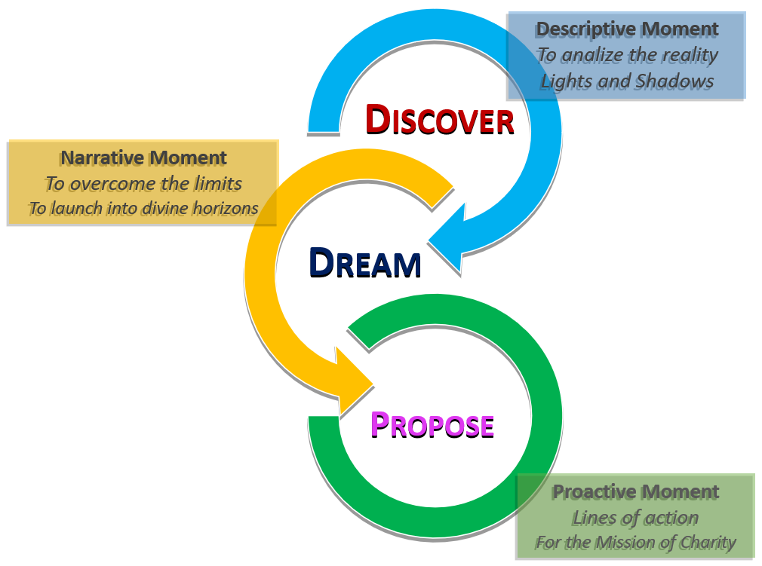
Here, at each level, we are called to formulate proposals to be presented to the next (the Communities to the Provincial Chapters and these to the General), and some concrete decisions already achievable in our community/province. As for the proposals, we must make sure that they have a specific goal to achieve, a prolonged action over time, described as a path to be implemented.

The thematic units of the 15th General Chapter
In the task of "Throwing ourselves into the fire of the new times", the General Council has chosen to focus attention on three thematic units that can be formulated through as many questions:
• Who? - Identity; Becoming Disciples.
• How? - Communion; Becoming Witnesses.
• For who? - Mission; Becoming Prophets.
The working methodology that we have seen in the previous pages will have to be applied to each of them. In the presentation, here below, of the thematic units, we have chosen not to provide a questionnaire with closed questions to answer. A series of questions would have made the job easier, but less engaging and, perhaps, less fruitful. We preferred to launch some provocations so that the confreres reflect and feel freer in the contribution to make.
More concrete directives on how to do the work will be given in the Personal Notebook that each of you will receive.
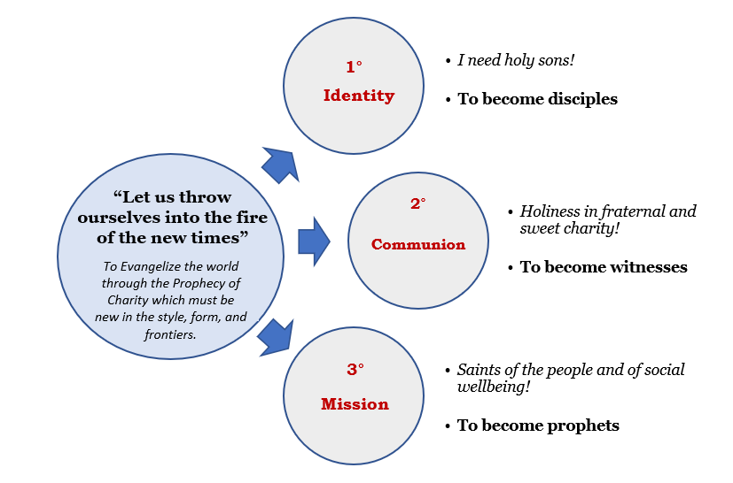
The perspective that will accompany us and that will connect the theme of the whole journey of the Chapter is the one indicated to us by Don Orione himself: the pursuit of holiness ("We must be saints", "we must become saints").
1st thematic unit: Identity
I need holy sons! (1914)
To become disciples

On March 3, 1914, thinking of future missionaries, Don Orione launches this heartfelt appeal: “Yes, we will be able to do great good; but I need holy sons! " (Scritti 2.76).
Wanting to implement this desire of the Founder, we face the theme of our identity as religious called to "Throw ourselves into the fire of the new times". This reflection allows us to further deepen what was said by the previous Chapter on the identity of the Religious and on his humanity.
It is true that God acts even in our frailty and uses our weakness to show the world the strength of His love for it. It is also true, however, that he calls us to a constant effort to conform to the person of Christ and His teaching by following the example of Don Orione and the encouragement of the saints and the Pope.
In this first unit, we are invited to look at the lofty ideal proposed to us, that of holiness that must permeate all moments of our life.
Don Orione showed us a great spirituality, a constant search for God's will, an unshakable trust in Divine Providence. This questions us about the relationship between our being men of God and being administrators of our works.
Pope Francis has shown us a different way to go to the people with a missionary drive that wants to reach everyone. He recommended mercy and tenderness as a style of the apostolate. This questions us about our way of approaching people.
We are busy working and we often do it with generosity and resourcefulness, but sometimes we are tired, disheartened, or demotivated. Perhaps some are afraid to insert themselves into our institutions, or they feel as those are no longer “ours”. This questions us about the roots of our being and our working, about our awareness of being "Orionine" and what this means concretely in daily life.
Perhaps in our life, the tiredness of everyday routine is taking over. This questions us as to what could be a new way of being Sons of Divine Providence dedicated wholeheartedly to the mission of God and of the Church.
So, inspired by Don Orione and Pope Francis, what style do we, the Sons of Divine Providence, have to take up to "Throw ourselves into the fire of the new times" and become disciples?

2nd thematic unit: communion
Holiness in fraternal and sweet charity! (1922)
To become witnesses
On 24 June 1922, speaking of Saint Pacomius and Saint Anthony the Abbot, Don Orione said that they were busy in many activities, but they cultivated "above all, holiness in fraternal and sweet charity" (Scritti 82,114).
We too are called to live "community holiness". We know well that living in a community is an essential characteristic of religious life and of our being Orionine. We know it, we believe it and we want it, but we cannot hide that, in everyday life, it is difficult to practice it.
The Gospel and the Magisterium remind us that the witness of fraternal life and mutual love is the most powerful weapon of our apostolate. This questions us about what witness our communities give to the people who come to us regularly.
Perhaps even here we are linked to old patterns, traditional styles that on the one hand safeguard fidelity to "community practices" but, on the other, do not encourage creativity, nor the external expressions of our being "brothers". We love each other, but sometimes we are shy to tell or show it to one another. To witness means "to show" and this questions us about what innovations we could introduce into our homes so that we can feel more about family style, reciprocal esteem, and mutual help.
New technologies allow us to be in contact with people spread over the 5 continents and this is a terrific thing. But often we are so caught up in it that we forget to look at who is physically next to us. We communicate with the world but we cannot communicate with those in the house. This questions us about the quality of our relationships, about how much time we dedicate to listening and talking to our brothers, about fraternal dynamics.
Over the years the awareness of belonging not only to a congregation but to a "charismatic family" has grown, where the spirit of Don Orione is expressed in a greater variety of forms. This questions us about how we experience this familiarity with the other members (PSMC, ISO, IMN, MLO).
So, what style of fraternity does it take to “throw ourselves into the fire of the new times” and become witnesses?
3rd thematic unit: Mission
Saints of the people and of social wellbeing! (1939)
To become prophets
In the famous note “Souls! Souls!" (probably on 1939), Don Orione wrote: " We must be saints, but we must be such saints that our saintliness does not limit itself to the faithful, nor remain only within the Church, but transcends and throws such a shining light, such a great life of love of God and man on society, that we are more than saints of the Church; we are saints of the people and saints of social wellbeing.” (Scritti 57,104c).
The "saints of the people and of social wellbeing": this is how Don Orione wants us. He told us to go out of the sacristy and Pope Francis reminded us that in the past people used to call "the priests who run". Today we can do more. The Holy Father proposes to us a triple conversion: pastoral and missionary (Evangelii gaudium); for an integral ecology (Laudato Si '); towards a fraternity without borders (Fratelli tutti).
The field of the apostolate is increasingly vast and "new poverties" emerge every day: there are those affected by the crisis caused by the pandemic, the refugees, the increasingly disoriented young people, and many others we meet in our environment, but who often we do not know how to recognize. Our Founder said: "We also need to rejuvenate in the way we work for souls: if we really want to go to the people and be effective, we must rejuvenate ourselves in many things, and we need a bath of well-understood modernity" (Scritti 52,221). This challenges us: do we still feel within us Don Orione's anxiety to run to the poor, and the least? Are we able to see the face of Christ in everyone? Are we concerned for those who are far away or are we satisfied with those who come to us? If our works and parishes are permeated by this apostolic anxiety, they will give a strong testimony of the charism and those who attend them will experience the sweetness of being part of a family.
One of the last Chapters invited us to start activities as pioneers with immediate and speedy schemes. This apostolic paradigm must be continued and strengthened. On the other hand, someone asks: How to manage the large institutions we have and that often cause us anxiety, concern for compliance with regulations, and sometimes even debts? Today, to manage our works, especially the largest and most complex ones, “goodwill” alone is no longer enough. Above all, competence, professionalism, and authority are needed.
The "new times" call us to manage our works differently from the past, in a certain sense unprecedented. We must ask ourselves if and in what way the religious can still manage the works or should they simply be left in the hands of qualified professionals. The choices we will make from what motivations will they be driven? Will they only be the result of a resignation that tries to "disguise" our unpreparedness?
So, what style of apostolate does it take to “throw ourselves into the fire of the new times” and become prophets?
Other particular themes
Given the vastness of the Congregation and the variety of environments in which it operates, each Community/Province is confronted with particular issues that may escape the three units indicated above. It is good that at all levels of participation, both in the personal or community phase and in the provincial one, these issues are presented.
The Provinces should be promoters in encouraging the communities to suggest what is important to them and, then, during the Provincial Chapter, they should evaluate what needs to be resolved at the local level and what should instead be presented to the General Chapter. Naturally, the possibility remains valid for each religious to address, in his own time, directly to the General Chapter.

Organization and Calendar
Beginning of the journey to the Chapter (31 May 2021)
The official start of the journey, with the convocation of the 15th General Chapter, is set for the day of the celebration of the Visitation of the Blessed Virgin Mary. This takes place at the Sanctuary of the Incoronata in Foggia, exactly one year before the beginning of the General Chapter. Similarly, in June, all the communities are called to organize a moment of prayer, according to the modalities that each Province will indicate.
2021
June – July - August | September - October | November - December
Personal Reflection | Chapters of the Community | Provincial Chapters
Consultation with Laypeople
Time for Prayer
The commitments for the year 2021 are presented here according to an indicative calendar; the provincial councils are called to define the times; the only constitutional obligation is that the Provincial Chapter be "celebrated at least six months before" the General Chapter (cf. Cost. art. 199).
Personal reflection (June / August 2021)
If we arrive at the community meeting (next phase) without first having prepared ourselves properly by reading and reflecting on the texts that are sent, we risk transforming the meeting into a formality, where the obvious things will be highlighted, and some more hidden, but perhaps more essential to our journey, ones may go unnoticed. The warm invitation is, therefore, that we dedicate a considerable amount of time to personal reading and to allow ourselves to be provoked by the texts through the action of the Spirit. The Personal Notebook is a helpful tool to do this job.
Chapter of the community or of the region (September / October 2021)
Each community reflects on the theme, with some involvement also of PSMC and laity, starting from the contribution that each religious has noted in the personal notebook for participation in the Chapter.
The aims of the Chapters of the Community are: to foster the participation and co-responsibility of all in the journey of the Congregation; and the elaboration of the community's contribution to the Provincial Chapter.
We must be careful not to let ourselves be caught up in the temptation of pessimism, of thinking that it is all useless work, that nothing ever changes; or be seized by mistrust. The contribution of all, if sincere, in the hands of Divine Providence, can bear unexpected fruits.
We leave it to the choice of the Provincial Council to see where it is appropriate that some communities numerically weak (or for other reasons) gather to work together so that dialogue may be more fruitful.
Consultation addressed to the other members of the Charismatic Family
It is the intention of the General Council to carry out, next September, an online inquiry to the members of the Charismatic Family on the style of the one proposed to the religious last year. The result will allow us to have a view of our works and communities from the outside, and can also be used by the Provincial Chapters.
Since the chapter is one year ahead, we will be able to make use also of the contributions that will arrive from secretariats and other conventions.
Provincial Chapter (November / December 2021)
Each Province assumes the contributions of the communities, evaluates them, and authoritatively elaborates the contribution of the Province to the General Chapter.
The purposes of the Provincial Chapter are:
- to elaborate the contribution of the Province to the General Chapter;
- deal with particular issues concerning the Province itself;
- to elect the Representatives to the General Chapter

2022
January | February | March - April | May | June
General Council | Pre-chapter commission |  | 31/05 - 18/06: 15th GC  23/06: 150th Birth of D. Orione
Time for Prayer
Pre-Chapter Commission (February 2022)
A pre-chapter commission, with religious from different provinces, collects, studies, and elaborates the contributions received from the provincial chapters.
The purposes of the Pre-Chapter Commission are:
• To study and organize the contributions received by compiling an Instrumentum laboris which will constitute the basic document for the work of the General Chapter.
• Prepare the Chapter from an organizational point of view: logistics, proposed calendar, subsidies, secretarial team, etc.
• Propose the text of the Chapter's regulations, which will be submitted for approval by the Chapter Assembly.
General Chapter (31 May - 18 June 2022)
The General Chapter has tasks and dynamics already established in the Constitutions and Norms and ordered in a proper Statute.
The main purposes of the General Chapter are:
• Deal with the central theme by revising the past and making a new plan for the six-year period;
• Address any other relevant and common issues;
• Elect the Superior General and the other members of the General Council.
Implementation of the General Chapter
Our Norms, at n. 175, indicate: "Each Province, within the year following the General Chapter, will hold a provincial assembly chaired by the Provincial Superior for planning the implementation of the decisions of the General Chapter and the solution of the problems of the Province. (...) The Vice Provinces and Delegations will also hold a similar meeting for the same purposes, open to all perpetually professed religious. "

All together at the Chapter for the Future of the Congregation

The General Chapter is a powerful instrument that God's Providence and the wisdom of the Church offer us for the renewal of the Congregation, but, for the event to produce true fruits, we must feel fully touched by it. We do the Chapter "all of us together", with prayer and commitment from the earliest stages and with the reflections that you will be able to send.
The word that, perhaps, has returned most frequently in these pages is "new". Innovations can stimulate, but they can also produce fear. "But if we allow doubts and fears to dampen our courage, instead of being creative we will remain comfortable and make no progress whatsoever. In this case, we will not take an active part in historical processes, but become mere onlookers as the Church [Congregation] gradually stagnates”(cf. EG 129).
The 15th General Chapter must help us to open up the horizon of expectations, set high goals, which does not mean impossible or unattainable ones; goals that allow us to take risks to help create a more just and humane world. Sometimes one gets the impression that the fear of facing the new is blocking the Congregation, limiting our creativity, and, in this way, reducing the strength of the legacy left to us by Don Orione. We are called to “more”, to love more, to serve more; not a "more" which is obstinate, but the fruit of a movement of generous love in search of God's will. "Let us all try to only love our Lord more, and more and more, and to unite ourselves more and more in charity and in love for our dear Congregation" (Scritti 4,187).
Don Orione was a priest who, with a clear mind and great trust in God, knew how to expand real possibilities and go further, believing in the dream of the Instaurare Omnia in Christo. We carry this humble audacity in our DNA and we must not lose it, as Pope Francis reminds us: "I invite everyone to be bold and creative in this task of rethinking the goals, structures, style, and methods of evangelization in their respective communities." (EG 33).
We invoke the intercession of Mary Most Holy, our Mother, of our Father Founder, of our Martyrs, so that from Heaven they accompany the steps of our journey towards the 15th General Chapter.
Let us end with the Prayer for the General Chapter:
Lord Jesus,
You who called us to follow you
as religious Sons of Divine Providence,
send your Spirit to enlighten our minds
and to inflame our heart
in this time of preparation
to the 15th General Chapter.

Renew us in the joy of living your Gospel
and revive in us the charism you have given us
through our Founder, St. Luigi Orione.

Grant that this time of grace
may be for all an opportunity for spiritual renewal
and strengthen that bond of charity in us,
that makes us taste the beauty of brotherly love.

Teach us to open our arms to all those
for which the Congregation carries out its mission of charity
and to throw ourselves courageously into the fire of the new times.

Give us the strength to be in the world,
prophets of communion and servants of those poor
that your goodness entrusts to our care.

We ask this through the intercession
of Mary Mother of Divine Providence
and of our holy Founder. Amen.

Yours in Christ,

P. Tarcísio G. Vieira  Superior General | Don Oreste Ferrari  Vicar General
P. Fernando Fornerod  General Councillor | P. Pierre Assamouan Kouassi  General Councillor
P. Laureano de la Red Merino  General Councillor | Don Fulvio Ferrari  General Bursar

