125 YEARS FROM THE PRIES TLY ORDINATION OF DON LOUIS ORIONE

TO LISTEN, DISCERN AND LIVE THE MISSION

Roma July 3, 2018

Dear young friends,
Brothers and Sisters in charge of youth pastoral ministry
in the Orionine Family.
We are very happy to write this letter to you. It is always beautiful to find a reason to meet.
Surely you are aware of the fact that in the next few months you will be at the centre of many celebrations in the Church. Yes! Many of the things happening in the next few months concern you. We are thinking of the XV General Assembly of the Synod of Bishops, which will take place in Rome in the month of October, and which, as you know, has as a title: "young people, the faith and vocational discernment". The work of preparation for such very important event has been hectic and is involving all of us; we expect abundant fruits when the assembly of bishops will meet together with Pope Francis. Straight after that, in January 2019, there will be the WYD in Panama, which has the title "Here I am the handmaid of the Lord, let it be done to me according to your word" (Lk 1,38); Here too we will celebrate the call of the Lord and our answer to Him, after the example of Mary. Furthermore, there will be many events that we will celebrate together as Orionine Family: the formation journeys, the meeting with other groups, and the missions of faith and charity that we will realize to be an "outgoing Church", building bridges for a more fraternal society.

In the horizon of our journey we would like to propose to you the celebration of a feast: on April 13, 2020 we will commemorate the 125th anniversary of priestly ordination of St. Luigi Orione. He was ordained at the age of 23: more or less your age or even younger than you. That day his life changed completely. Apart from the chronological aspect, we know that each day is a proper day to accept the call of the Lord to be his, in order to be all for the poor.
Our father, St. Luigi Orione, since the time when he started the "St. Luigi" oratory, could not live his dream without sharing it with other young friends. We can always find him igniting the spark of an authentic faith and boundless charity. We too would like to rekindle the fire of this faith and the mission of this charity. So our proposal is a simple one: we will have a gathering in Tortona from the 1st to the 5th of July 2020 for all the orionine young people in the world celebrating, in this way, the great gift of a father, a saint who gathers us as family. In order to live this appointment as a truly spiritual, charismatic and missionary journey, we will celebrate together the Year of the Orionine Youth from June 1st 2019 till June 30 2020. The theme which will enliven all the activities will be: "Listen, discern and live the mission".
Why such a long but important time? Because we want to renew our experience of being Orionine, so that Don Orione may count on us, on you. With this project we want to make the experience of being a family and part of the universal Church; to deepen our journey of faith and of belonging to the orionine family; to live some moments of strong spirituality; to listen to the appeal of the Lord who calls us to witness with enthusiasm our vocation as young missionaries; to discover and cooperate in other youth initiatives.
Do you remember when don Orione met Mario Ivaldi, the young boy who had given up going to catechism? In that moment Luigi left everything he was doing, to listen to Mario and to console him. After that meeting they were not the same anymore, their life had changed. That happens because when two young people dream together everything becomes new: "do you want to come back tomorrow? " Luigi said to Mario; then he added: "find some of your friends, bring them here too, because I want to start a small youth club or oratory; then you will see how many beautiful things we will do". Surely you remember these words because someone said the same to you while inviting you to join the Sunday oratory, or the youth group of the parish, of the school or the Piccolo Cottolengo. That invitation to take the first of many steps is an experience that renews itself in the heart of many orionine young people since then till today.
It was not just a question of words; from that meeting full of faith and joy a mission was born: to live every meeting with others under the sign of charity. It is in this perspective of trust and love that surely you experienced the presence of the Lord in your own life. We meet the Lord when we serve the others. But serving others involves the sacrifice of one's own life, without measures, or better, with the only measure of our ability to love from the heart. And this mission, a demanding one, but which fills life with happiness, Don Orione proposes it to another young man called Biagio Marabotto when he invited him to be part of our family. He reassures him: "we have a happy life because it is enough for us to have Jesus".
But all this is not always so clear. How do we meet Jesus in our own life and in the history of our community? How to distinguish the Word of the Spirit among many other words that we listen to? And again: how will we take the right decision: the one that opens the doors to our happiness? The events of our lives are silent or ambiguous, as they can be interpreted differently. Illuminating its meaning in terms of a decision requires a path of discernment. What was then, the style of discernment with which Luigi Orione helped many young people to take the most fundamental decisions of their life? He was a father for many young people, helping them to listen to the voice of the Lord in their hearts; making a faith pour forth in them which was founded on the daily experience that Divine Providence loves everyone, making sure that everything contributes to the good and, finally, kindling in each of them, first the spark and then the "two flames of the one and sacred fire: to love God and to love the brothers".
Dear young orionine friends, we invite you therefore to live this journey with generosity. Not to be spectators, but true protagonists of this time full of experiences that will help us to re- launch our identity and mission. To join with others ... to organize ... The meeting is a journey to be lived together, in the group, with other companions on the way. We feel that Don Orione walks with us, and as he did with others, even today he helps us to live with enthusiasm our commitment to follow the Lord Jesus.
We entrust to Mary Most Holy all the initiatives that we will live during the Year of the Young Orionine 2019-2020 and during the international gathering in Tortona.
Hail Mary and forward...!
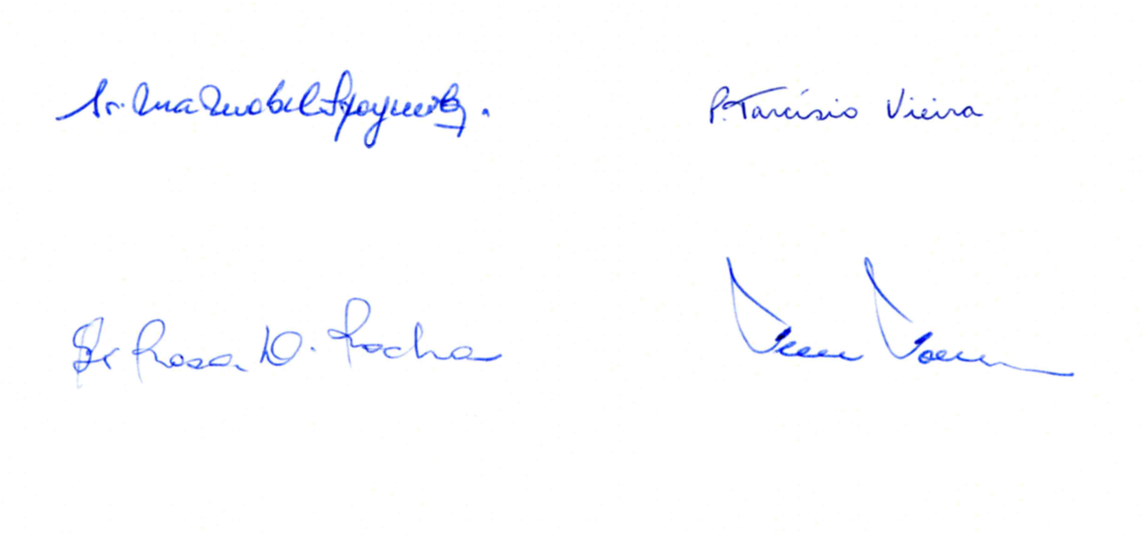

Sr. Maria Mabel Spagnuolo Fr. Tarcisio Vieira
General Superior PSMC General Superior FDP

Sr. Maria Rosa Delgado Rocha Fr. Fernando Fornerod
General Councillor General Councillor

